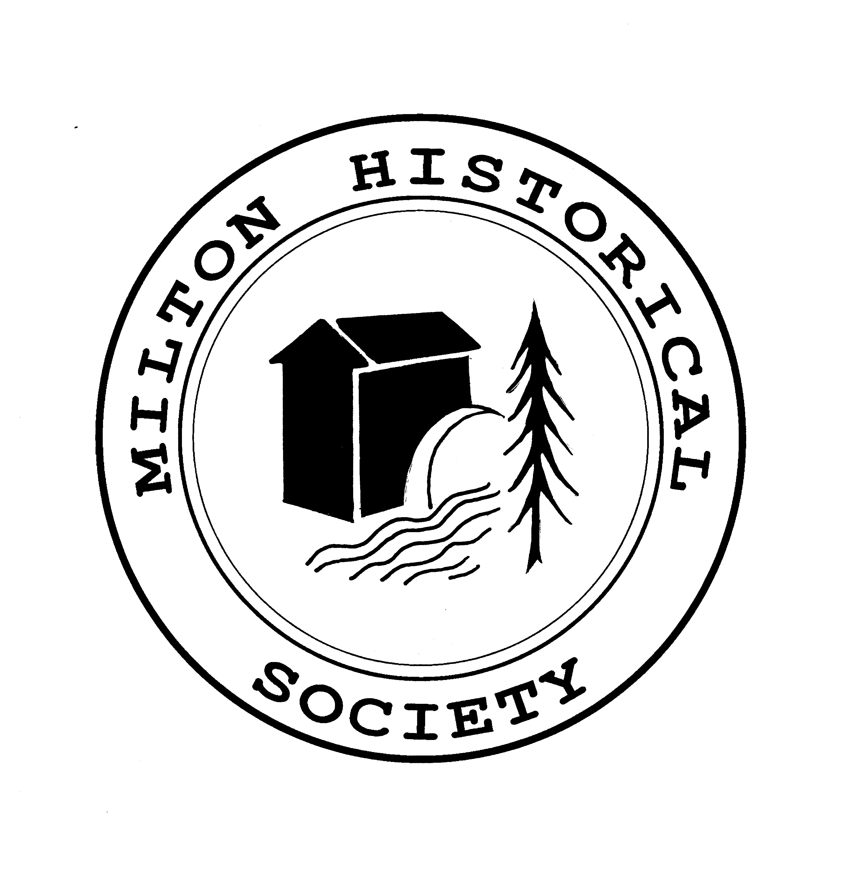
The Milton Historical Society
Preserving Milton’s History for Future Generations
MEMBERSHIP FORM

Name: ______________________________________________________
Address: ______________________________________________________
______________________________________________________
Phone: ______________________________________________________
Email: ______________________________________________________

Membership Dues: Jan. to Dec. (Check categories that apply)
___New Member or ___ Renewal
___Single $30 ___ SR. 65+ $25 ___ Family $45 ___ Youth (free)
___Corporate GOLD $500 ___Corporate SILVER $250 ___ Corporate BRONZE $100
___Yes, as a new member I wish to receive the Journal and other e-communications.
Volunteers Help Us Forge Our Future
We know all members have certain unique talents, skills and abilities.
We ask you to share these, as our society relies on your active support and involvement.
These are just a few of the areas you can help the society with:
__Office Support/Communications __Artistic Opportunities
__Social Events __Building Stewardship
__Finance Opportunities __Museum Greeters
__Education Opportunities __Archives: Computer Data Entry, Digitization of Archival Records, Cataloguing and Preservation
(Please check those that interest you as listed on the back of this form)

Donations
I wish to make a separate donation to MHS in the sum of _________________
Donations and payments can be made on line through PayPal from our website.
(A tax receipt will be issued for all donations totaling $25.00 or more)
Note: The Milton Historical Society has set up a foundation
under the “Community Foundation of Halton North” (CFHN).
You can also donate through this foundation towards the Milton Historical Society.
Please contact our Society for further information.
The Milton Historical Society is a registered charity # 110041358RR0001

Payment may be made via Interac e-Transfer to historymilton@gmail.com
Please make cheques payable to Milton Historical Society
Mail completed form/remittance to:
The Milton Historical Society
16 James St., Milton, ON L9T 2P4

